Two properties of binary heap are structure property & heap order property.

Probe Seq. using Quadratic Probing

Linear Quadratic

i i

i+1 i+12

i+2 i+22

Big O-Notation

T(N)= O(F(n)) : T(N) ≤ F(N)

T(N)= **Ω**(F(n)) : T(N) ≥ F(N)

T(N)= **Θ**(F(n)) : T(N) = F(N)

T(N)= o(F(n)) : T(N) < F(N)

A problem is said to be polynomial (or in the class P) if it can be solved in time polynomial in its size (linear & binary search). A problem is said to be nondeterministically polynomial (or in the class NP) if a conjectured answer can be verified in time polynomial in its size.(satisfiability problem) A problem is NP-hard if it is at least as hard as any problem in NP. A problem is NP- complete if it is NP-hard and also in NP itself.

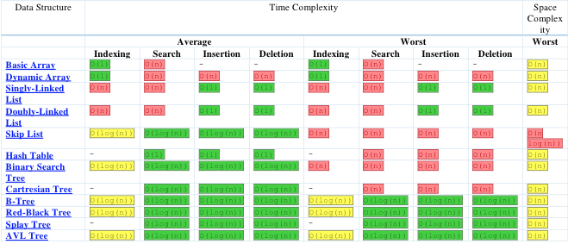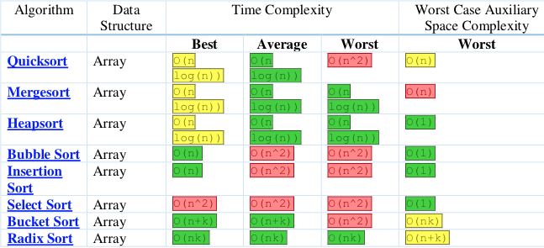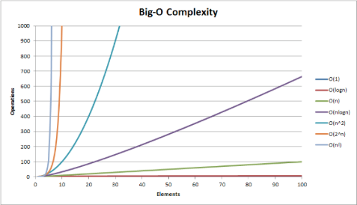

Hash Table: 2 resolutions for fixing a collision in Hash. 1) Separate Chain (implemented linked list) 2) Open addressing (linear probing, quadratic probing, double hashing)…size of hashing should be a prime number *n* greater than 2 b/c if it is not a prime, it has more risk of having collisions.

H(key) = key % 5 [size 5] 4,6,20,14,31,29

4%5=4…6%5=1…20%5=0…14%5=4…31%5=1…29%5=4

Linear Probing resolves a collision during hashing by examining consecutive locations in the hash, table-beginning at the original hash index to find the next available one.

Collisions that are resolved w/ linear probing cause groups of consecutive locations in the hash table to be occupied (cluster).

Binary Search: algorithm compares search key values with key value of middle element of array. If keys match, index is returned. Else, if key greater (right) less (left), it halves the number of its to check w/ each iteration, so locating an item takes log time. (Dichotomy divide & conquer search algorithm).

Merge Sort: Preserves the input order of equal elements in the sorted outputs.

Kruskal Time Complexity: O(elog(e))

Double Hashing (Linear Probing): 2 steps of a typical hash function to perform…1) convert the search key to an integer code…2) compress hash code into range of indices for hash table

Double Hashing uses a 2nd hash function to compute increments in a key-dependent way. Motivation: improving search time, simple index (Olog(n)), B-tree, Hashing O(1).

